Pothole Detection Using Deep Learning

Project Team:

Hamad Aljumah  
Abdulaziz Alosel  
Alreashed Alreashed  
Abdulrhman Alothman

# 1. Introduction

This project focuses on developing a deep learning model to detect potholes in roads using images. The primary objective is to automate the detection process to enhance road maintenance and safety. Addressing this issue is crucial because potholes can cause traffic jams and accidents. By automating the detection process, we aim to contribute to smoother traffic flow and reduce the risk of accidents caused by damaged road surfaces.

# 2. Dataset Description

The dataset used in this project consists of images categorized into two classes: normal road surfaces and surfaces with potholes. The dataset is divided into training, validation, and testing sets.

# 3. Model Architecture

The deep learning model employed in this project is a Convolutional Neural Network (CNN). The architecture includes several convolutional layers followed by pooling layers and fully connected layers, designed to extract features and perform classification.

# 4. Training and Validation

The model was trained using a dataset of images, with techniques such as data augmentation applied to improve generalization. Validation was conducted to tune hyperparameters and avoid overfitting.

# 5. Results

The model's performance was evaluated using accuracy, precision, recall and F1. The results indicate that the model is effective in detecting potholes, with a high accuracy and minimal false positives.

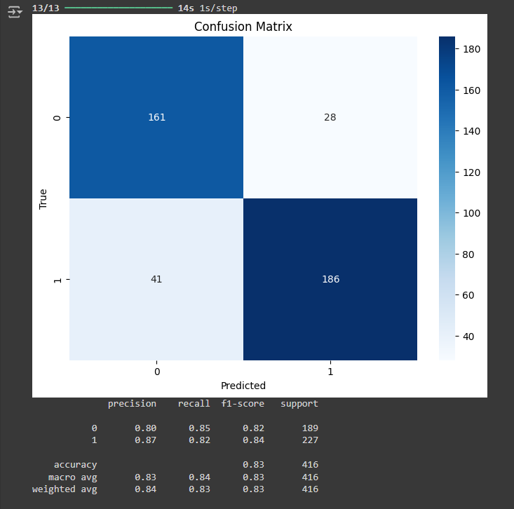

# 6. Conclusion

This project successfully demonstrates the potential of deep learning in automating pothole detection. Future work could involve refining the model and applying it to larger datasets, as well as integrating the model into a real-time road monitoring system.